Current, Voltage and Resistance in Series and Parallel Circuits
Resource: http://hyperphysics.phy-astr.gsu.edu/hbase/electric/ohmlaw.html
Current, I .
Electrical current (I) is the rate of electrical charge movement in a circuit i.e. how much charge flows through the circuit in a given time.
More strictly, it is the number of Coulombs of charge passing a point in a circuit in a unit of time (where 1 Coulomb is a collective term for approx. 6 x 10¹⁸ electrons):
1 Ampere (Amp, A) = 1 Coulomb of charge passing through a point in a circuit in 1 second.
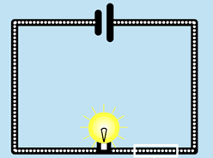
C
C
C
C
C
C
C
C
The number of Coulombs passing through a point in a circuit in 1 second is the current in Amps.
n.b. electrons do not really move around in dense, round packets of 6 x 10¹⁸ – why not?
___________________________________________________
The Current Law states that the current flowing into any junction in a circuit is the same as the current flowing out of that junction i.e. the number of coulombs moving into and out of any component per second is equal. Charge is conserved – this means that electrons are not removed or added at any point in a circuit.
In a series circuit the current is equal at all points, like water flow in a single pipe. In a parallel circuit, the current “splits” and “rejoins” at the branch points of the circuit before and after the parallel components.
A₃
A₁

A₅
A₄
A₆
A₂₂

Series: A₁ = ______ Parallel: A₃ = ______ = ______________________

Voltage, V.
Voltage is the change in electrical potential energy per Coulomb of charge as it flows through a component.
Power supplies increase electrical potential energy creating a voltage gain, in a similar way to a pump that raises water, increasing gravitational potential energy.
Other components in a circuit decrease potential energy and cause a voltage drop. Because they have resistance, the electrons do work as they move through components like resistors and bulbs, and electrical potential energy is transferred into heat (and light). Hence, the energy level of the electrons is reduced.
Voltage is also known as Potential Difference (P.D.) and is a comparison of electrical potential energy between two points in a circuit.
1 Volt, (V) = 1 Joule per Coulomb of charge
The Voltage Law states that in any closed path the voltage changes must sum to zero. This means that energy must be conserved: E_{in} = E_{out} i.e. the energy, E before a transfer must be the same as the total energy after a transfer.
Hence, no matter what path you take through an electric circuit, if you return to your starting point you must measure the same voltage (energy change).
Notice that the potential differences before and after the supply (a voltage ‘booster’) and the resistor (a voltage ‘dropper’) in all of these circuits is 10V i.e. the change in energy potential is 10 Joules per Coulomb (J/C):
+10 V
+10 V
+10 V
+10 V

E _{in}

+10 J/C
E _{out}

-10 J/C
E _{out}

-10 J/C
E _{out}

-10 J/C
E _{out}

-10 J/C
E _{in}

+10 J/C
E _{in}

+10 J/C

0 V
0 V
0 V
0 V
A Coulomb of charge with a relatively high electrical potential of 10 Joules or a voltage of 10 Volts. 10J of electrical energy was transferred by the cell.
10
10
10
10

A Coulomb of charge with a relatively low electrical potential of 0 Joules, a voltage of 0 Volts. 10 J of energy per Coulomb was transferred to the resistor and lost as heat.
0
0
0
0

The change in energy potential per coulomb of charge is the potential difference or voltage. In this example, the potential difference is 10V.

Resistance, R.
Electrical resistance is a measure of the opposition of current in a conductor i.e. how easily charge can flow through it. It can be thought of as a type of ‘electrical friction’ that limits current. Resistance is measured in Ohm’s, Ω.
1 Ohm (Ω) of resistance draws a current of 1 Amp from a voltage of 1 Volt.
The resistance of a conductor is increased by:
- Increasing length: greater total number of collisions between the ionic nuclei of the conductor and the electrons flowing through it
- Decreasing width or cross-sectional area: more collisions per unit area
- Increasing temperature: greater heat or kinetic energy of particles means more collisions and interference between ionic nuclei and moving electrons

For an animation of current flowing through a resistor see
https://phet.colorado.edu/en/simulation/battery-resistor-circuit and check “show cores”

Why do resistors heat up when the supply voltage is increased?
________________________________________________________________________________________________________________________________________________________________________________________________________________________________________________________________________________________________________________________________________________________________________________________________________________________________________________________

Ohm’s Law: the relationship between current, voltage and resistance.
Two factors determine the size of the current in a DC (Direct Current: unidirectional) circuit:
- ‘Push’: the size of the supply voltage, $V$ _{s}: the bigger the voltage, the greater the strength of the electrical field, and therefore the greater the force acting on the electrical charges in the circuit, hence the greater the current.
- ‘Pull’: the total resistance of the circuit, $R$ _{T} in terms of its components (items in the circuit): the greater the electrical resistance, the greater the opposition to electron flow through, and therefore the lower the current.
If the supply voltage and the resistance of a component are known, the current through that component can be calculated using an arrangement of this formula for Ohm’s Law, rearranged for I:

$$I=\frac{V}{R}$$
I = Current in Amps, A V = Voltage or Potential Difference in volts, V R = resistance, Ohms, Ω
Ohm’s Law states that the current through (many) conductors is directly proportional to the voltage applied to them i.e. the relationship is linear:
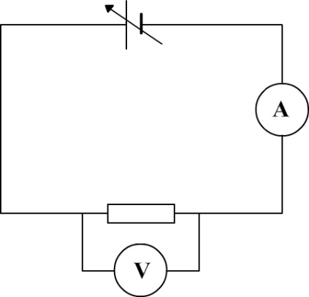
Voltage, $V$ (V)
Current, $I$ (A)
Low Resistance, $R$ (Ω)
High Resistance, $R$ (Ω)

Maths connections:
The slope of a straight line is constant. In maths, a linear relationship is represented by y = mx +c, where m is a constant that equals the slope, and c is the $y$-intercept.
It follows that the slope, $m= \frac{y}{x}$ . The slope of the line is calculated from $\frac{rise}{run}$ or the $\frac{change in x}{change in y}$ .
On a graph of current vs. voltage,$y$ = current, I, and $x$ = voltage, V, then slope = $\frac{I}{V}$
This constant is the reciprocal of the resistance, $\frac{1}{R}$ and is equal to the slope of the line, hence $\frac{1}{R} = \frac{I}{V}$
If we flip this over to remove the reciprocal, we get $\frac{R}{1} = \frac{V}{I}$ which is equal to R $= \frac{V}{I}$
i.e. the resistance of a component (Ω) equals the voltage across it (V) divided by the current through it (A).

See: https://phet.colorado.edu/en/simulation/ohms-law and investigate the effects of changing $V$ and $I$
For a basic circuit containing a single Ohmic resistor:
As VOLTAGE _______________________________, circuit CURRENT ________________________________.
As RESISTANCE ______________________________, CURRENT _________________________________ and VOLTAGE ________________________________________________________________________________.
The total resistance of a series circuit is the sum of the components’ resistances:
R_{T} = R₁+R₂ +R₃
Hence, in a series circuit, adding extra components adds extra resistance. This reduces current hence there are fewer Coulombs passing through the components every second. Therefore the rate of “supply” of Coulombs to the circuit components is reduced and so the rate of energy transfer through the component is reduced e.g. less heat and light emitted by a bulb each second.
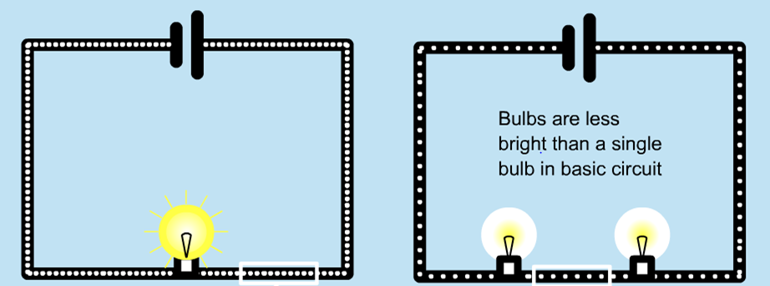

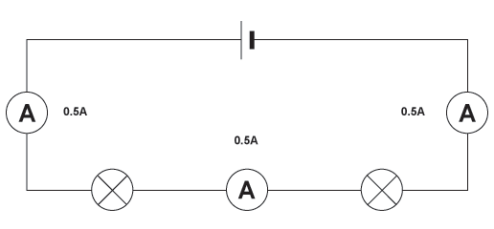
The Current Law states that the current flowing into any junction is the same as the current flowing out of that junction. In a series circuit the current is therefore the same at all points i.e. the current through one component will be equal to the total current of the circuit: I₁ = I₂ = I₃
The resistance of the circuit, R_{T} =

The resistance of each bulb, R₁ and R₂ =

1
2
3
6 V
0.5A V

In parallel circuits, adding extra components in parallel creates new pathways for current to be drawn from the supply. Each new parallel component is effectively connected directly to the supply and therefore draws its own current, independently of components in other parallel connections.
As each parallel connection is effectively a separate connection to the supply, the overall resistance of the circuit is decreased. Therefore the total current from the power supply is increased.
The total resistance of a parallel circuit is calculated by:
$\frac{1}{R_{T}}$ ₌$\frac{1}{R_{1}}$ ₊ $\frac{1}{R_{2}}$₊$\frac{1}{R_{3}}$
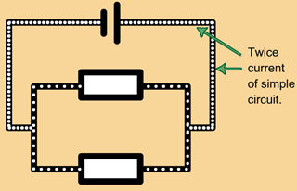
n.b. for the purposes of NCEA L1 you can assume that the wires connecting the components to the supply have no resistance and therefore there is no voltage drop along their length – it is as if parallel components have their own separate connection to the supply

In a parallel circuit, the Current Law means that the main current through the power supply I_{S} is equal to the sum of the current in the parallel branches, or:
I_{S} = I₁ + I₂
If you know the any two variables of the supply voltage, current or total resistance of a parallel circuit you can calculate the missing third using one of the formulae for Ohm’s Law:
$$R=\frac{V}{I} I=\frac{V}{R} V=IR$$
A₁
A_{s}

R₃
R₂
4V
R₁
V₁

A₂
A₃

A₁ reads 1.5A.  R₁ has a resistance of 4Ω.  What would voltmeter V₁ read? |  | A_{s} reads 6A.  R₂ has a resistance of 2Ω.  What is the resistance of R₃?
Build these circuits and check your calculations at
https://phet.colorado.edu/en/simulation/circuit-construction-kit-dc

In a river, current is the rate of water movement i.e. how much water flows through the river in a given time; 1 cumec = 1 cubic metre of water per second.
‘Ohmic’ conductors obey Ohm’s Law: their resistance remains constant over a wide range of voltage and temperatures. Non-Ohmic conductors’ resistance can vary with voltage and temperature: as temperature increases, their resistance increases (due to greater kinetic energy of particles and more collisions/interference with electrons
Like adding obstructions into a river increases the friction acting against the flowing water.
Think of it as adding additional pathways for water to flow from a source: the current is no longer restricted to a single path and therefore the flow of water is eased.

